Register for IBM Cloud

INDHU CLOUD ACCOUNT

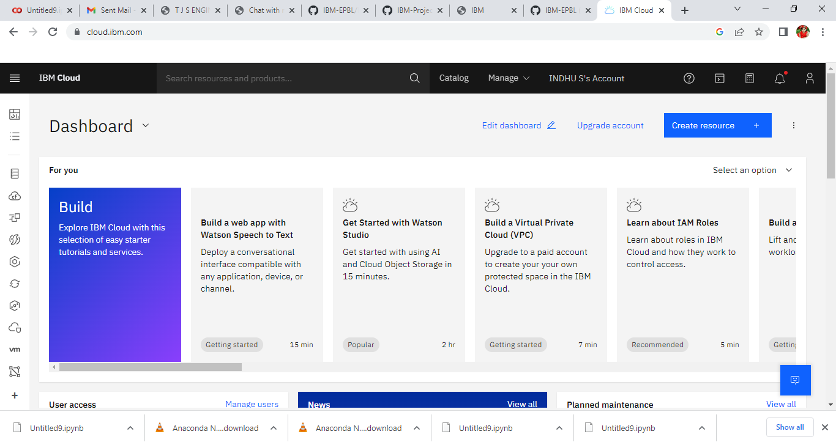

PRADNYA DAHAKE CLOUD ACCOUNT

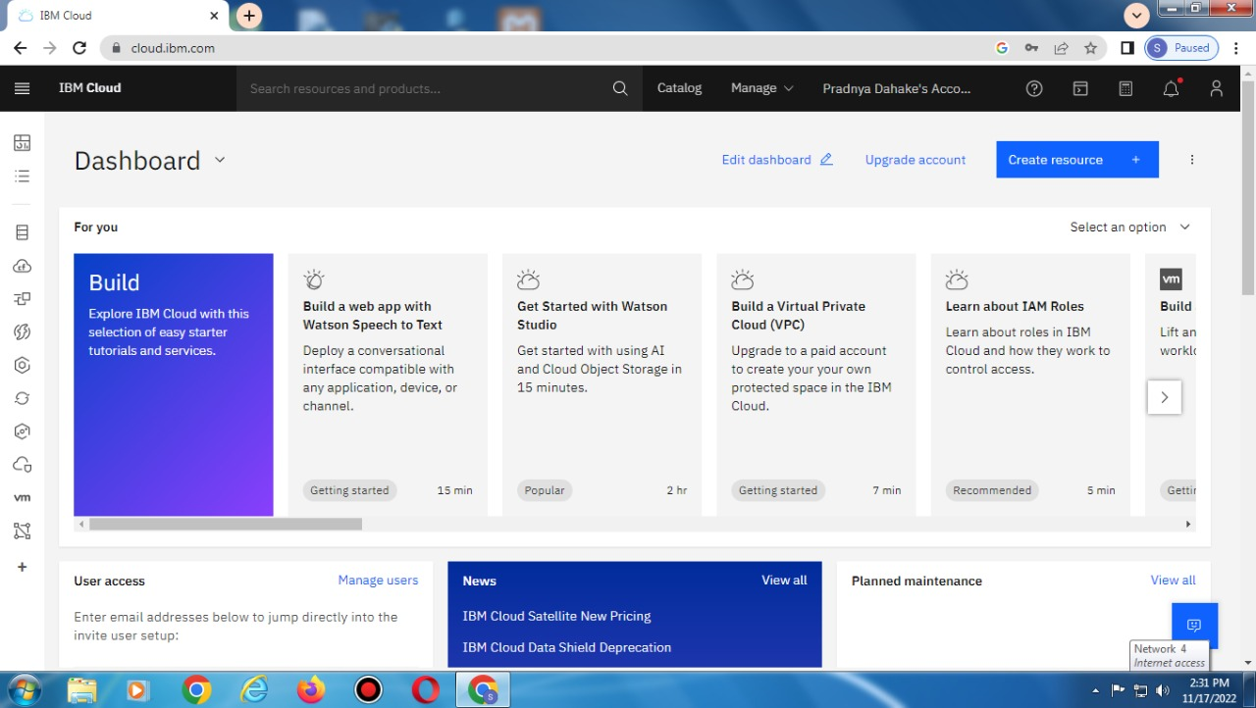

DEEPIKA CLOUD ACCOUNT

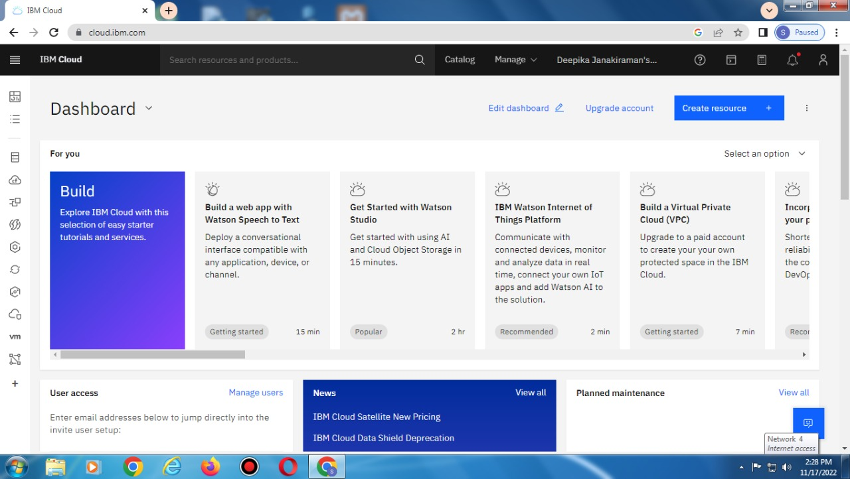

SYED HUSSAIN CLOUD ACCOUNT

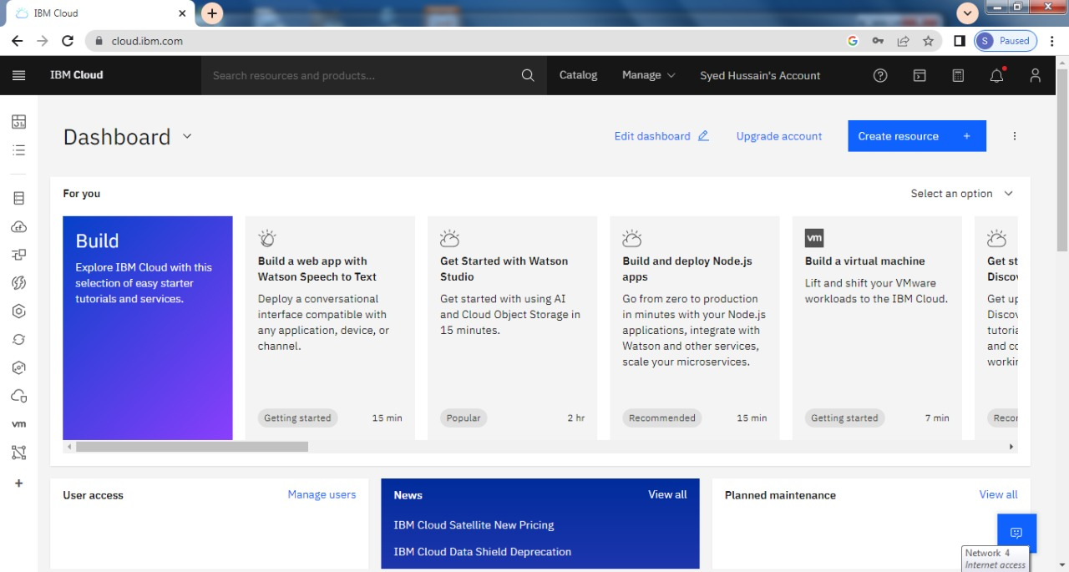

NAVEEN KUMAR CLOUD ACCOUNT

